
Data sheet (lab 4)

Course: CSE209 Electrical Circuits
Experimental name: Bias Point Detail Analysis of DC Circuit with Dependent Sources Using Pspice Schematics

Submitted By:

D.M. Rafiun -Bin- Masud
ID: 2019-3-60-137
Department of CSE

Submitted to:

Rashedul Amin Tuhin
Senior Lecturer,
Department of Computer Science and Engineering

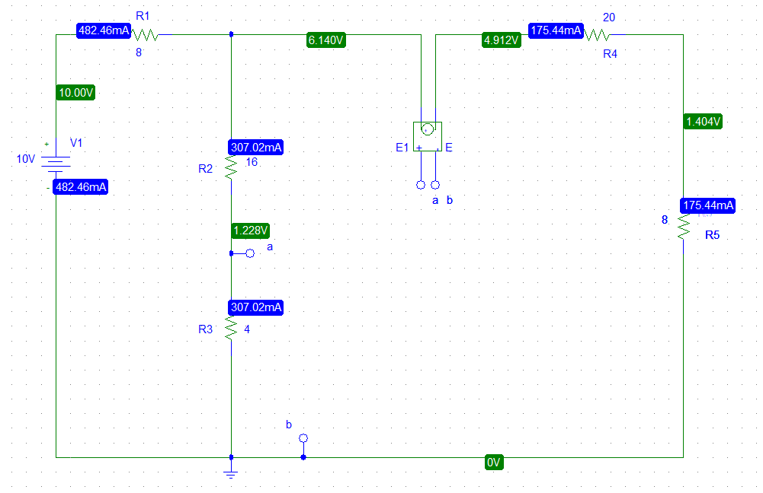
Figure 1
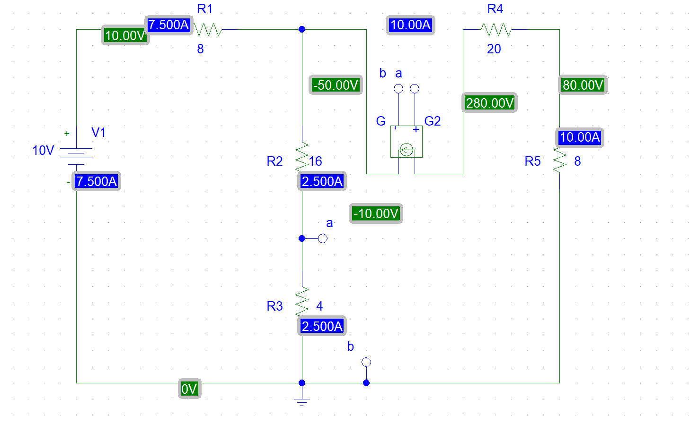
Figure 2

Schematics Netlist of Figure 1:

V_V1 $N_0001 0 10V
R_R1 $N_0001 $N_0002 8
R_R2 a $N_0002 16
R_R3 0 a 4
R_R4 $N_0004 $N_0003 20
E_E1 $N_0002 $N_0003 a 0 1
R_R5 $N_0004 0 8

Schematics Netlist of Figure 2:

V_V1 $N_0001 0 10V
R_R1 $N_0001 $N_0002 8
R_R2 a $N_0002 16
R_R3 0 a 4
R_R5 0 $N_0003 8
R_R4 $N_0004 $N_0003 20
G_G2 $N_0004 $N_0002 a 0 1

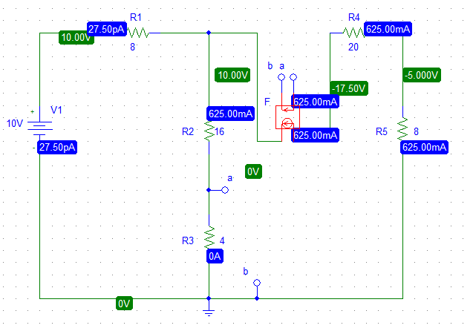
Figure 3
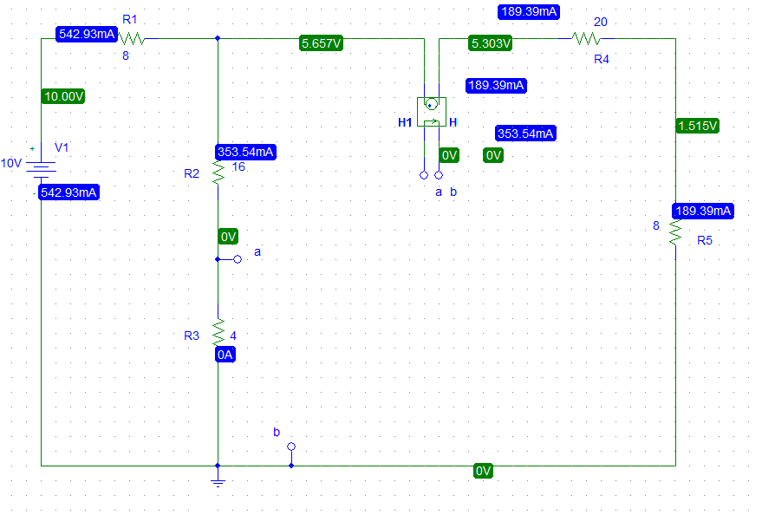
Figure 4

Schematics Netlist of Figure 3:

V_V1 $N_0001 0 10V
R_R1 $N_0001 $N_0002 8
R_R2 a $N_0002 16
R_R3 0 a 4
R_R5 0 $N_0003 8
R_R4 $N_0004 $N_0003 20
F_F1 $N_0004 $N_0002 VF_F1 1
VF_F1 a 0 0V

Schematics Netlist of Figure 4:

V_V1 $N_0001 0 10V
R_R1 $N_0001 $N_0002 8
R_R2 a $N_0002 16
R_R3 0 a 4
R_R5 $N_0003 0 8
R_R4 $N_0003 $N_0004 20
H_H1 $N_0002 $N_0004 VH_H1 1
VH_H1 a 0 0V

Practice problem:

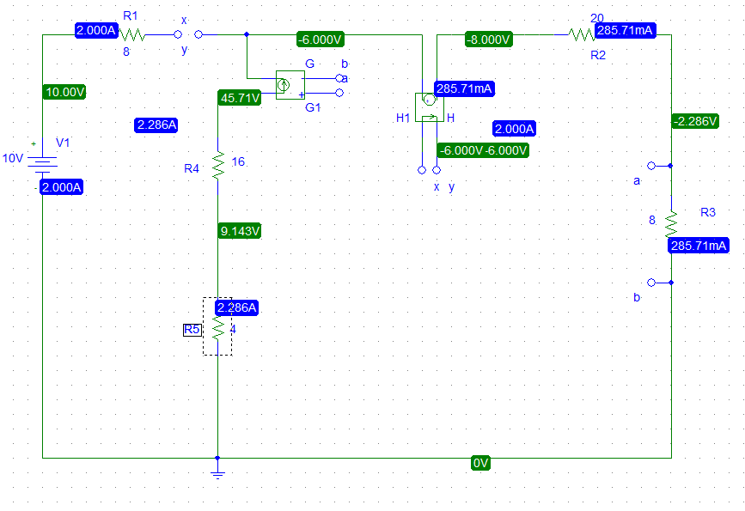
Figure 5

Schematics Netlist of Figure 5:

V_V1 $N_0001 0 10V
H_H1 y $N_0002 VH_H1 1
VH_H1 x y 0V
R_R1 $N_0001 x 8
G_G1 $N_0003 y a 0 1
R_R2 a $N_0002 20
R_R3 a 0 8
R_R4 $N_0004 $N_0003 16
R_R5 0 $N_0004 4

